中外学生上海一日游( 3月12日)
Shanghai 1-day trip with Chinese students（on March 12）
路线一：城隍庙——豫园——观光巴士——外滩
Route 1：The Old City God’s Temple—Yu Garden—Tour bus —The Bund
行程  Schedule | 9:30 集合乘坐地铁，到达城隍庙  9:30am, take subway to Yu Garden/Old City God’s Temple.（¥30）  11:00 午餐  11:00am lunch  14:30 集合乘坐观光巴士到外滩  14:30pm, take tour bus (¥30) to the Bund.  16:00行程结束，可自行晚餐，自行返校  16:00pm, Trip ends with dinner and back to school on your own.
路线二：东华大学松江校区——东华大学校史馆——广富林遗址公园
Route 2：DHU Songjiang Campus --- DHU History Museum ---Guang Fu Lin Relics Park
行程  Schedule | 9:30 集合乘坐地前往松江校区  9:30am, take subway to Songjiang Campus;  11:00到达松江校区参观松江校区及校史馆  11:00am, visit Campus & DHU History Museum.  12:30 与中国学生一起野餐、游戏。  12:30pm, picnic & play with Chinese students  14:30 参观广富林遗址公园  14:30pm,Guang Fu Lin Relics Park  16:00行程结束，可自行晚餐，自行返校  16:00pm, Trip ends with dinner and back to school on your own.
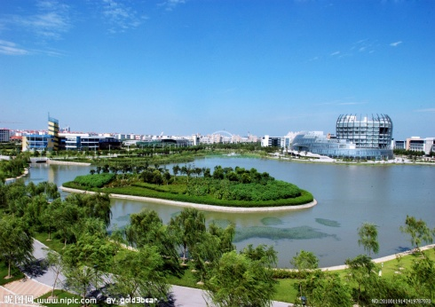
★参与者将免费获得东华大学纪念版的上海公交卡一张。（价值50元,内有交通费20元）
Get a DHU commemorative Shanghai public transport card for free.
(Valued￥50, includes transportation fee ￥20)
★3月12日（星期六）早上9:30在ICES门口集合。9:30am, 12st.Mar. (Sat.) gather outside of ICES.
★每条旅游路线限额30人，报满为止。 30 people for each route, availability is limited.
★游览时以小组为单位，5-6人为一组，每组由1名ITALK的中国学生带队游览。
Visit in a group of 5 or 6 people led by a Chinese student.
★景点费用和餐费自理。 Tickets and food expense not provided.
报名方式Registration：需提前进行网上报名 Registration Online in advance http://apply.ices.cn/
报名时间：3月7日-3月9日 Registration time: 7 Mar.- 9 Mar.
如在网上报名时遇到问题请到ICES 111办公室进行咨询。
If you have any problems when register online, please contact ICES 111 office .

网上报名步骤
Registration Online procedure

http://apply.ices.cn
网页右上角可以选择语言。
You can choose the language; Click English or other language on the upper right corner of the website page.

登录。Log In

老生 Old Students
用户名User Name: 护照号码 Passport Number
密码Password: 生日（8位） Date of Birth (yyyymmdd)

新生 New Students
初始用户名(邮箱地址)： Original User Name (your e-mail address)
密码Password: 报名注册时自己设置的密码 Password set by yourself when you register (apply.ices.cn)

如果在第一次登录时遇到问题，请及时到ICES111办公室进行咨询报名。
If you have problem when Log in, Please go to ICES office111 to register.

登录后，点击网页左边“活动申请”一栏。
Click Activities Application on Left Side of the Website page
报名成功后，我们会以短信形式跟您确认。
We will confirm the time and route by SMS to complete registration.
根据活动路线时间进行报名。
Click Register for activities you want.

网上报名时间: 3月7日-3月9日 7 Mar.- 9 Mar.

请在报名时登记正确的手机号码,以确保我们可以联系到你。
Please write the correct phone number while registering to make sure we can contact you.

